Session on Pediatric Ophthalmology in National Forum of Ophthalmologists
October 3-5, 2012

One day meeting on Retinopathy of Prematurity
October 6, 2012

Organized and hosted by Moscow Helmholtz Research Institute for Eye Diseases,
Moscow, Russia.
Local Organizer:
Professor Ludmilla Katargina, Chair, Pediatric Ophthalmology, Department of Ophthalmology, Moscow Helmholtz Research Institute for Eye Diseases.

International Attendees:
Professor Clare E. Gilbert, MD, FRCOphth, London School of Hygiene & Tropical Medicine, UK
Graham Quinn MD, MSCE, The Children’s Hospital of Philadelphia, Univ Pennsylvania, USA
Alan Richards, MD, Louisiana State University, Shreveport, Louisiana, USA

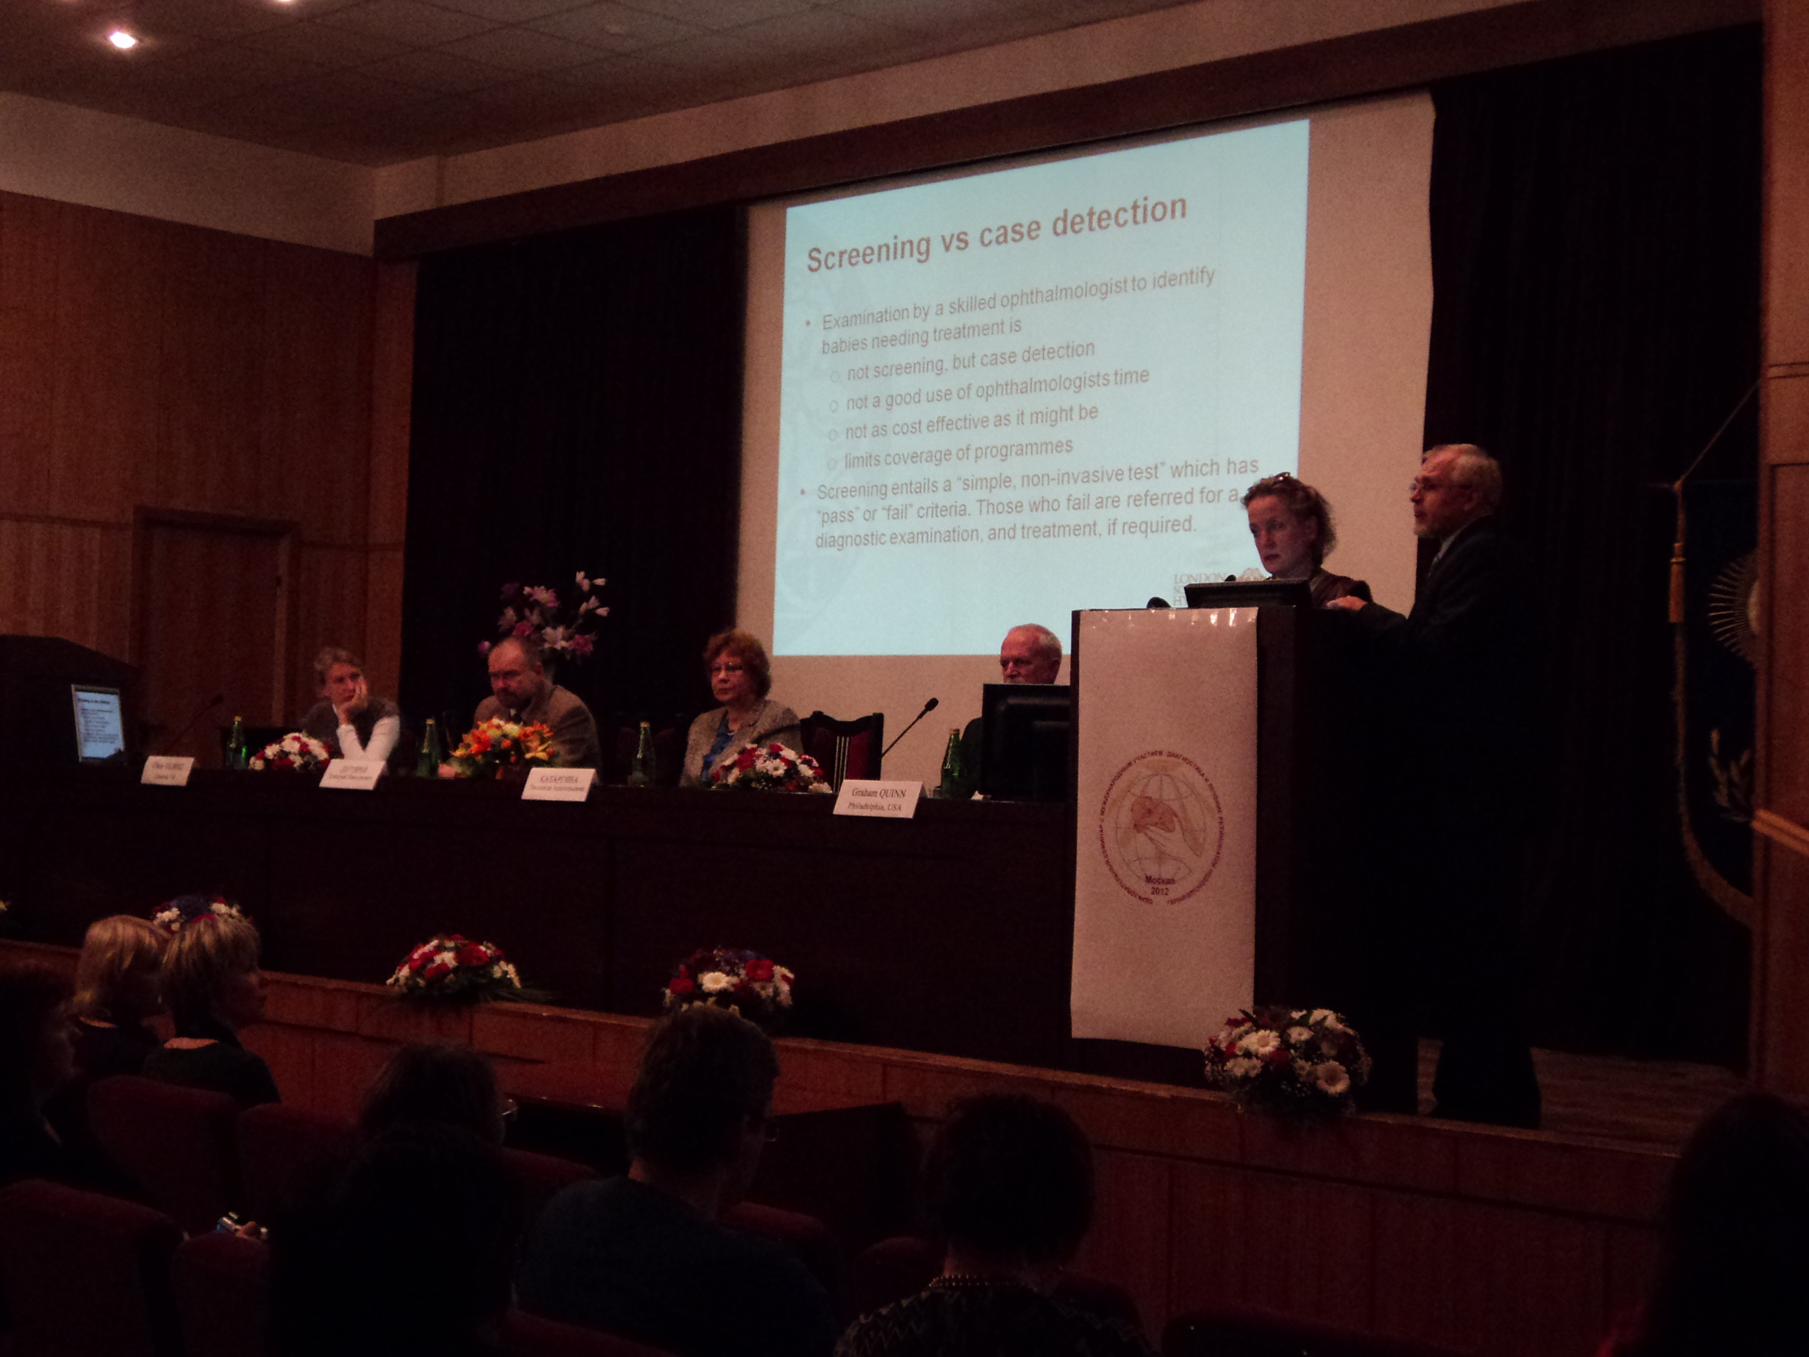

Opening session of the second national symposium on retinopathy of prematurity


With support from Shreveport Sees Russia
Background:
Russia is an enormous country with a population of approximately 140 million. It is estimated that there are over 1.5 million births each year. The infant mortality rate is 10.08/1000 although this varies by region, likely being lower in urban areas, in the western region. It is estimated that at least 1% of births have birth weights of less than 1550g, which means that approximately 20,000 births/year require neonatal care and are at risk of retinopathy of prematurity (ROP).

In November 2009, a National Ophthalmology Forum was held, the focus being pediatric ophthalmology and medical retina. During the pediatric ophthalmology session there were several presentations on ROP, including one by Professor Clare Gilbert who had been invited to the Forum by Professor Ludmila Katargina, Chair of Pediatric Ophthalmology at the Helmhotz Institute of Ophthalmology. She is also advisor to the Ministry of Health on Pediatric Ophthalmology.

First national symposium on ROP:
A symposium on ROP in Russia was held in Moscow on April 7-8 2011, at the Helmholtz Research Institute for Eye Diseases. This meeting was also called by Professor Katargina, Chair of Pediatric Ophthalmology, and was attended by ophthalmologists from many regions in Russia.

Another National Ophthalmology Forum was held in Moscow, October 4-5th 2012, and again had half a day dedicated to Pediatric Ophthalmology. During this session Professor Clare Gilbert and Dr. Graham Quinn made presentations to approximately 300 individuals from all over Russia. Professor Gilbert spoke on the prevalence of blindness in children due to ROP, highlighting that a systematic approach is needed for prevention. Dr Quinn presented data on the treatment of severe ROP by laser photocoagulation, the internationally recognized treatment, and presented data from a recent clinical trial on intraocular injection of anti-VEGF therapy. Dr Quinn emphasized that laser photocoagulation remains the standard treatment for severe ROP.

A National Forum on ROP:
The National Ophthalmology Forum was followed by a national symposium on ROP, which was held on October 6, 2012 at the Helmholtz Research Institute. Professor Katargina called the meeting. Over 200 individuals attended, many being ophthalmologists experienced in ROP from Moscow, St Petersburg and other major cities across the country. Neonatologists also attended, including Professor DN Degtyarev, Deputy Director on Scientific Work at the Federal Research Center for Obstetrics, Gynecology and Perinatology. There were also 3 international attendees: Professor C Gilbert (UK), Dr. G Quinn and Dr. A Richards (USA). The symposium opened with greetings from Professor Katargina. She then made a presentation on the availability of modern ophthalmologic investigative tools with the aim to encourage their more general use in pediatric ophthalmology and then information on the indications for treatment of ROP. Professor Katargina announced that the Ministry of Health, being aware of the ongoing and potentially increasing problem of blindness due to ROP, has agreed to supply each of the 49 regions of the country with a wide-field digital imaging system for detecting babies with severe disease, a laser for treatment and an indirect ophthalmoscope. This equipment will be delivered to the regions in early 2013.

This was followed by a presentation on the “Screening vs examination of babies at risk of ROP” by Professor C Gilbert. She highlighted the potential for screening, such as digital imaging, for detection of eyes with potentially serious ROP so that the child may undergo a thorough diagnostic examination by an ophthalmologist experienced in ROP, followed by treated if indicated. Professor Gilbert highlighted the need for careful evaluation of this approach to increasing coverage of ROP programmes.

Professor DN Degtyarev provided the neonatologists perspective on ROP, highlighting that improving neonatal care leads to a decrease in the risk of ROP. Professor Degtyarev described the Ministry of Health’s guidelines and policies that are now in place concerning the standards that are required for neonatal care, saying that these are constantly being revised and updated. He also stated that neonatal care was expanding but was not yet of high enough quality in many neonatal units and that poor nursing levels and lack of equipment were important issues.

Next, a report on the current status in St Petersburg was presented by Professor Sadasheva. Previously the ROP screening criteria were 1500g or less or 32 weeks GA or less, but this was recently changed to the MOH required criteria of less than 35 weeks gestation or less than 2000g BW. The MOH requires that a neonatologist and a nurse be present at the ROP eye examinations and that indirect ophthalmoscopy or digital imaging are the mandated techniques for examination. Prof Sadasheva also noted that a new, more effective dilating drug Midrimax is coming on the market soon. In St Petersburg, the IMR is low compared to much of Russia and ophthalmic care in the NICU is supplemented by digital imaging. Laser photocoagulation is available in the NICU.

Dr G Quinn presented a talk entitled “Treatment of serious ROP” and reviewed the use of laser photocoagulation as the standard of care and the issue of anti-VEGF (Avastin) injections. A strong argument was made that the outcomes of the two techniques are quite different. Laser photocoagulation has a long history of use in randomized clinical trials and that is has excellent results in experienced hands. Although Avastin has been used in a clinical trial (BEAT-ROP), the trial had serious methodologic limitations. What is needed now is a more thorough investigation of ocular and systemic effects of infants treated with Avastin and randomized clinical trials that also include long term ocular and systemic complications. In the discussion it became apparent that Avastin is only rarely used in Russia. Dr. Quinn then presented information on the USA experience in telemedicine.

This was followed by a presentation by a representative from Clarity, makers of the RetCAm digital imaging system. Further presentations were made on treatment indications for severe ROP, late complications of ROP, myopia and prematurity and visual rehabilitation. A presentation was made by Dr. O Diskalenko, a vitreoretinal surgeon and Head of the Eye Department at Leningrad Regional Child Clinical Hospital, a national referral centre, who described his experience with retinal detachments due to ROP. Dr Diskalenko sees many very difficult cases and performs vitrectomy for both stage 4 and stage 5 ROP. These cases were either not treated at all, or were inadequately or inappropriately treated by ophthalmologists unfamiliar with ROP. As a consequence of the cases he treats, Dr Diskalenko recommends cryotherapy over laser photocoagulation for severe ROP. Professors Katargina and Gilbert and Dr Quinn commented on the difficulty of the cases he described, but strongly advocated that laser photocoagulation be standard of care and that this should be done by individuals with adequate skills.

A final scheduled presentation was made on the developing legal problems in ROP in Russia. Professor Fomina stated the most common issues that lead to legal issues are the lack of proper equipment for detection and treatment, miscommunication between physicians, poor parental understanding of the risks of ROP or the baby’s eye status, and babies lost to follow-up.

A final session was presented by Dr Quinn who presented digital images of eyes with different stages of ROP, which involved participants commenting on the changes and the action they would take.

Conclusions:
Much is happening that is very positive in Russia: the need for improvements in neonatal care is recognized, and the Ministry of Health is committed to reducing blindness due to ROP. There is now an urgent need to build on this, which will entail developing ROP programs that are efficient and effective, developing skills amongst ophthalmologists in the detection and treatment of ROP, and building closer working relationships between ophthalmologists, neonatologists and neonatal nurses.

Next Steps:
Professor Katargina indicated interest in developing a joint neonatology/ophthalmology meeting in early 2013. She hoped that Prof Gilbert, Dr. Quinn, and an international expert on neonatology could attend.

Acknowledgements:
Financial support was provided by the Shreveport Sees Russia for travel and expenses of the international attendees, Professor C. Gilbert and Dr. G. Quinn.

